BROWSER HISTORY SIMULATOR
#include <iostream>
#include <stack>
#include <vector>
#include <string>
using namespace std;

class BrowserHistory {
private:
stack<string> backStack;
stack<string> forwardStack;
string currentPage;

public:
BrowserHistory(string homepage) {
currentPage = homepage;
}

void visit(string url) {
backStack.push(currentPage);
currentPage = url;

// clear forward history
while (!forwardStack.empty()) {
forwardStack.pop();
}

cout << "Visited: " << currentPage << endl;

// OPTIONAL: open in real browser (Windows only)
// system(("start " + url).c_str());
}

void back() {
if (backStack.empty()) {
cout << "No pages in back history\n";
return;
}

forwardStack.push(currentPage);
currentPage = backStack.top();
backStack.pop();

cout << "Current Page: " << currentPage << endl;
}

void forward() {
if (forwardStack.empty()) {
cout << "No pages in forward history\n";
return;
}

backStack.push(currentPage);
currentPage = forwardStack.top();
forwardStack.pop();

cout << "Current Page: " << currentPage << endl;
}

void display() {
cout << "Current Page: " << currentPage << endl;
}

// 🔥 Feature 1: Show full history
void showHistory() {
stack<string> temp = backStack;
vector<string> history;

while (!temp.empty()) {
history.push_back(temp.top());
temp.pop();
}

cout << "\n--- Browsing History ---\n";
for (int i = history.size() - 1; i >= 0; i--) {
cout << history[i] << " -> ";
}
cout << currentPage << endl;
}

// 🔥 Feature 2: Clear history
void clearHistory() {
while (!backStack.empty()) backStack.pop();
while (!forwardStack.empty()) forwardStack.pop();

cout << "History Cleared!\n";
}
};

int main() {
BrowserHistory browser("home.com");

int choice;
string url;

while (true) {
cout << "\n--- Browser History Simulator ---\n";
cout << "1. Visit New Page\n";
cout << "2. Go Back\n";
cout << "3. Go Forward\n";
cout << "4. Show Current Page\n";
cout << "5. Show Full History\n";
cout << "6. Clear History\n";
cout << "7. Exit\n";
cout << "Enter choice: ";
cin >> choice;

switch (choice) {
case 1:
cout << "Enter URL: ";
cin >> url;
browser.visit(url);
break;

case 2:
browser.back();
break;

case 3:
browser.forward();
break;

case 4:
browser.display();
break;

case 5:
browser.showHistory();
break;

case 6:
browser.clearHistory();
break;

case 7:
cout << "Exiting...\n";
return 0;

default:
cout << "Invalid choice!\n";
}
}
}
OUTPUT:
Step 1:

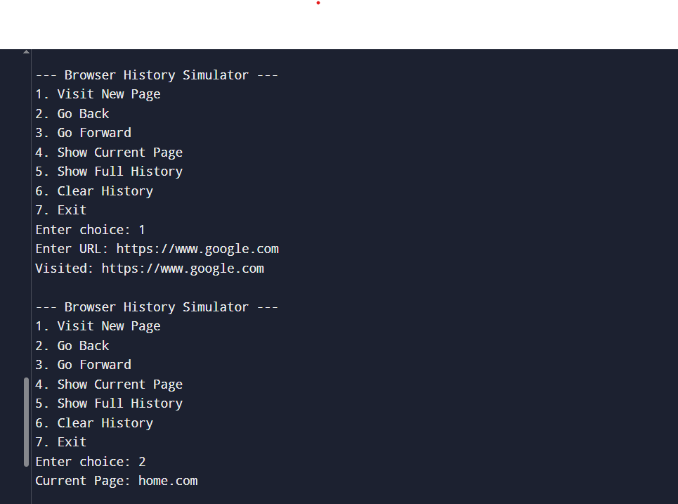
Step 2:
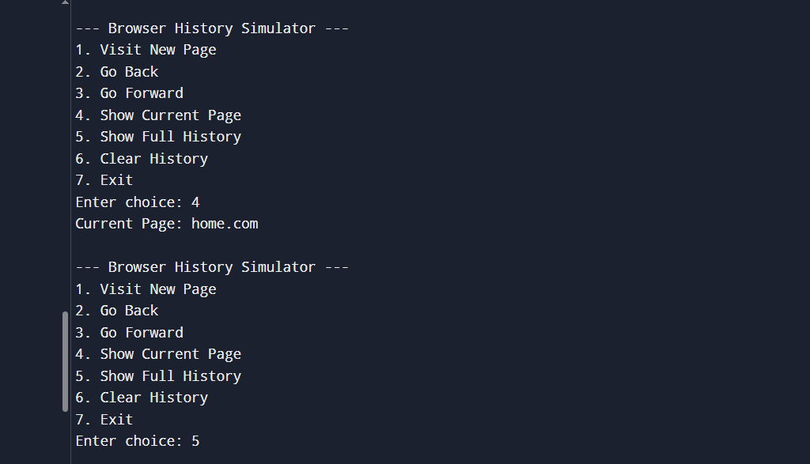

Step 3: